**Project 4 Report - EBO**

D11315807

Ardiawan Bagus Harisa

Department of CSIE

**Tasks:**

1. Define four vertices for a rectangle.

2. Define six indices for two triangles.

3. Bind an EBO with the indices.

4. Use glDrawElements() to draw.

**How to use my program:**

1. First, you must have the freeglut and glew library installed.
2. For my convenience, I use VS Studio for debugging.
3. Just run the debug by pressing F5. You will get the following result:

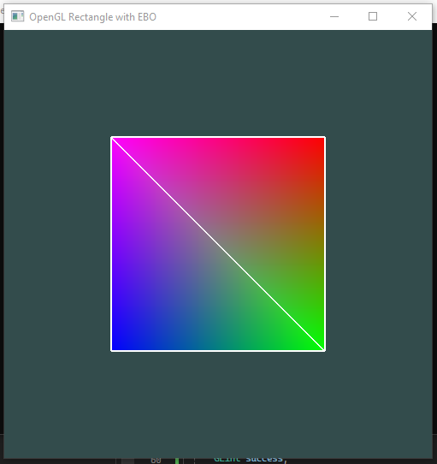

**Program:**

1. **Define a rectangle**

Similar to the Project 3, we need to provide the points/ vertices to define the rectangle. I am still using this tutorial as reference: <https://learnopengl.com/Getting-started/Hello-Triangle>.

Here we must define the four vertices that will be used to define the rectangle (which is actually constructed from two triangles). All vertices for the shape is declared in *vertices[]* array, and the triangles are actually declared in the *indices[]* array.

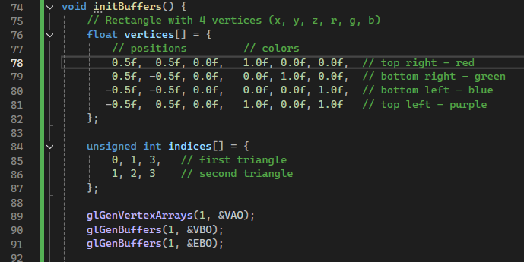

1. **Define six indices**

From the code above, we create two triangles from 6 indices. Then declare the buffer objects and the shader program, and bind them.

1. **Bind EBO with rectangle’s indices**

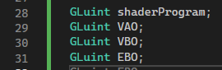

The process really just the same with the project 3, only added EBO. The EBO object that was just created then is bond to the target array buffer (element array buffer), which is buffer type that stores indices, to specify how those vertices are connected to make primitives shape (in this case, triangles). The declaration of those frame objects and the binding processes are declare din the *initBuffer()* function. The static draw is used to optimize the static graphic.

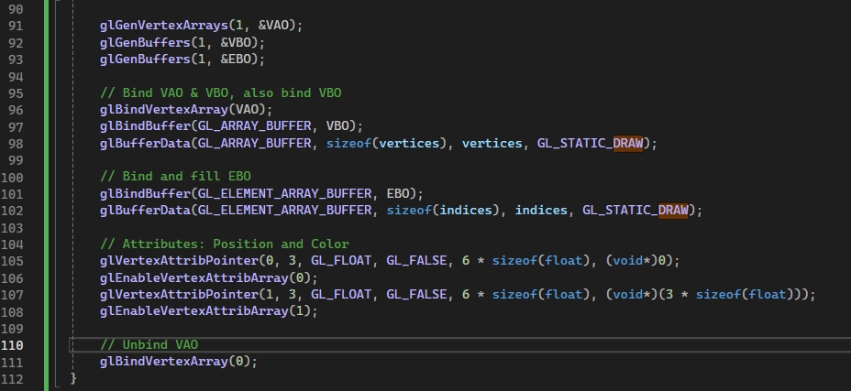

1. **Draw using glDrawElements()**

The drawing function calling occurs in the display which will be called in glut’s display function. The line 120th, we draw the rectangles out of triangles using *glDrawElements().* Here I use indices stored on EBO instead of specifying all vertex directly, to reference vertices in the VBO. No redundant work. Then just command OpenGL to run the commands using glFLush().

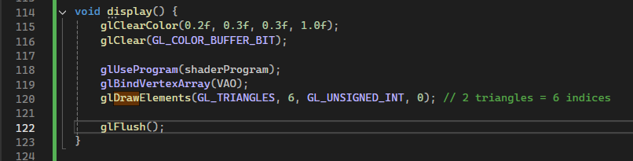

Then just call display on the main function similarly like we call shader initialization and buffer initialization.

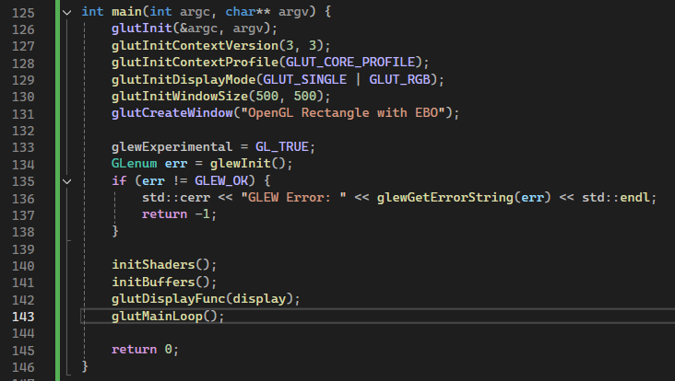

Here are the shaders initialization including the declarations.

// Shader program declaration

const char* vertexShaderSource = R"(

#version 330 core

layout(location = 0) in vec3 aPos;

layout(location = 1) in vec3 aColor;

out vec3 vertexColor;

void main() {

gl_Position = vec4(aPos, 1.0);

vertexColor = aColor;

}

)";

const char* fragmentShaderSource = R"(

#version 330 core

in vec3 vertexColor;

out vec4 FragColor;

void main() {

FragColor = vec4(vertexColor, 1.0);

}

)";

// Shader program initialization

void initShaders() {

// Vertex Shader

GLuint vertexShader = glCreateShader(GL_VERTEX_SHADER);

glShaderSource(vertexShader, 1, &vertexShaderSource, NULL);

glCompileShader(vertexShader);

GLint success;

glGetShaderiv(vertexShader, GL_COMPILE_STATUS, &success);

if (!success) {

char infoLog[512];

glGetShaderInfoLog(vertexShader, 512, NULL, infoLog);

std::cerr << "Vertex Shader Compilation Failed\n" << infoLog << std::endl;

}

// Fragment Shader

GLuint fragmentShader = glCreateShader(GL_FRAGMENT_SHADER);

glShaderSource(fragmentShader, 1, &fragmentShaderSource, NULL);

glCompileShader(fragmentShader);

glGetShaderiv(fragmentShader, GL_COMPILE_STATUS, &success);

if (!success) {

char infoLog[512];

glGetShaderInfoLog(fragmentShader, 512, NULL, infoLog);

std::cerr << "Fragment Shader Compilation Failed\n" << infoLog << std::endl;

}

// Shader Program

shaderProgram = glCreateProgram();

glAttachShader(shaderProgram, vertexShader);

glAttachShader(shaderProgram, fragmentShader);

glLinkProgram(shaderProgram);

glGetProgramiv(shaderProgram, GL_LINK_STATUS, &success);

if (!success) {

char infoLog[512];

glGetProgramInfoLog(shaderProgram, 512, NULL, infoLog);

std::cerr << "Shader Program Linking Failed\n" << infoLog << std::endl;

}

glDeleteShader(vertexShader);

glDeleteShader(fragmentShader);

}

The result:

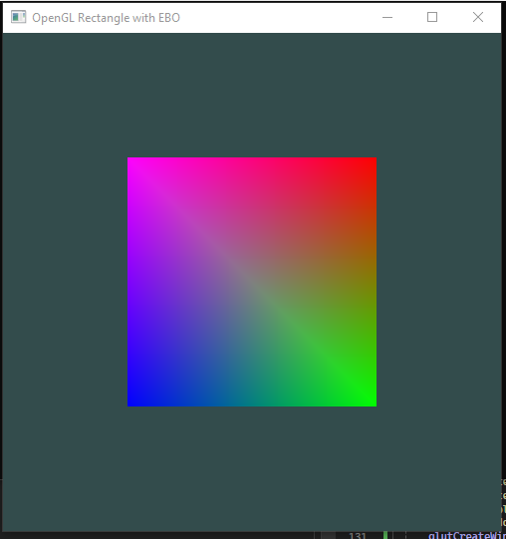

And I tried to create the outline to show the rectangles.



Create the vertex shader and fragment shader for the line. In shader code, we must provide the version of the GLSL being used, it corresponds to the OpenGL version. It takes a 3D position (aPos) as input, and the location = 0 means that this input is bound to attribute location 0 in the vertex data. In the main function, it converts the position into a 4D vector by adding w component with 1.0 (for the homogeneous coordinates for transformations). Also declare the variable for the line shader.

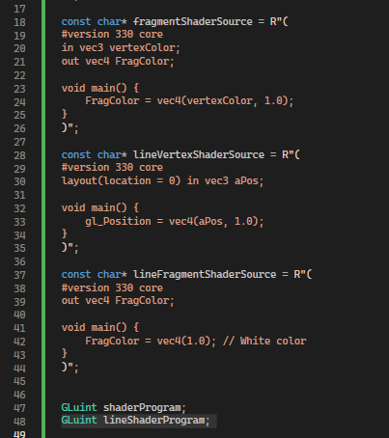

Update the *initShader()* function, add the binding of the newly line shader. Then delete it as a standalone shader because it is not needed.

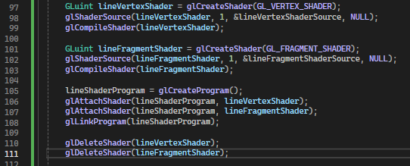

And the last step is just updating the *display()* function to draw the outline using the shader.

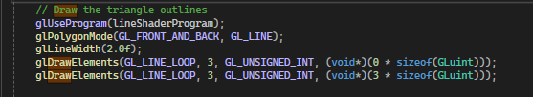

**Source code:**

#include <GL/glew.h>

#include <GL/freeglut.h>

#include <iostream>

const char* vertexShaderSource = R"(

#version 330 core

layout(location = 0) in vec3 aPos;

layout(location = 1) in vec3 aColor;

out vec3 vertexColor;

void main() {

gl_Position = vec4(aPos, 1.0);

vertexColor = aColor;

}

)";

const char* fragmentShaderSource = R"(

#version 330 core

in vec3 vertexColor;

out vec4 FragColor;

void main() {

FragColor = vec4(vertexColor, 1.0);

}

)";

const char* lineVertexShaderSource = R"(

#version 330 core

layout(location = 0) in vec3 aPos;

void main() {

gl_Position = vec4(aPos, 1.0);

}

)";

const char* lineFragmentShaderSource = R"(

#version 330 core

out vec4 FragColor;

void main() {

FragColor = vec4(1.0); // White color

}

)";

GLuint shaderProgram;

GLuint lineShaderProgram;

GLuint VAO;

GLuint VBO;

GLuint EBO;

void initShaders() {

// Vertex Shader

GLuint vertexShader = glCreateShader(GL_VERTEX_SHADER);

glShaderSource(vertexShader, 1, &vertexShaderSource, NULL);

glCompileShader(vertexShader);

GLint success;

glGetShaderiv(vertexShader, GL_COMPILE_STATUS, &success);

if (!success) {

char infoLog[512];

glGetShaderInfoLog(vertexShader, 512, NULL, infoLog);

std::cerr << "Vertex Shader Compilation Failed\n" << infoLog << std::endl;

}

// Fragment Shader

GLuint fragmentShader = glCreateShader(GL_FRAGMENT_SHADER);

glShaderSource(fragmentShader, 1, &fragmentShaderSource, NULL);

glCompileShader(fragmentShader);

glGetShaderiv(fragmentShader, GL_COMPILE_STATUS, &success);

if (!success) {

char infoLog[512];

glGetShaderInfoLog(fragmentShader, 512, NULL, infoLog);

std::cerr << "Fragment Shader Compilation Failed\n" << infoLog << std::endl;

}

// Shader Program

shaderProgram = glCreateProgram();

glAttachShader(shaderProgram, vertexShader);

glAttachShader(shaderProgram, fragmentShader);

glLinkProgram(shaderProgram);

glGetProgramiv(shaderProgram, GL_LINK_STATUS, &success);

if (!success) {

char infoLog[512];

glGetProgramInfoLog(shaderProgram, 512, NULL, infoLog);

std::cerr << "Shader Program Linking Failed\n" << infoLog << std::endl;

}

glDeleteShader(vertexShader);

glDeleteShader(fragmentShader);

// Line shader compilation

GLuint lineVertexShader = glCreateShader(GL_VERTEX_SHADER);

glShaderSource(lineVertexShader, 1, &lineVertexShaderSource, NULL);

glCompileShader(lineVertexShader);

GLuint lineFragmentShader = glCreateShader(GL_FRAGMENT_SHADER);

glShaderSource(lineFragmentShader, 1, &lineFragmentShaderSource, NULL);

glCompileShader(lineFragmentShader);

lineShaderProgram = glCreateProgram();

glAttachShader(lineShaderProgram, lineVertexShader);

glAttachShader(lineShaderProgram, lineFragmentShader);

glLinkProgram(lineShaderProgram);

glDeleteShader(lineVertexShader);

glDeleteShader(lineFragmentShader);

}

void initBuffers() {

// Rectangle with 4 vertices (x, y, z, r, g, b)

float vertices[] = {

// positions // colors

0.5f, 0.5f, 0.0f, 1.0f, 0.0f, 0.0f, // top right - red

0.5f, -0.5f, 0.0f, 0.0f, 1.0f, 0.0f, // bottom right - green

-0.5f, -0.5f, 0.0f, 0.0f, 0.0f, 1.0f, // bottom left - blue

-0.5f, 0.5f, 0.0f, 1.0f, 0.0f, 1.0f // top left - purple

};

unsigned int indices[] = {

0, 1, 3, // first triangle

1, 2, 3 // second triangle

};

glGenVertexArrays(1, &VAO);

glGenBuffers(1, &VBO);

glGenBuffers(1, &EBO);

// Bind VAO & VBO, also bind VBO

glBindVertexArray(VAO);

glBindBuffer(GL_ARRAY_BUFFER, VBO);

glBufferData(GL_ARRAY_BUFFER, sizeof(vertices), vertices, GL_STATIC_DRAW);

// Bind and fill EBO

glBindBuffer(GL_ELEMENT_ARRAY_BUFFER, EBO);

glBufferData(GL_ELEMENT_ARRAY_BUFFER, sizeof(indices), indices, GL_STATIC_DRAW);

// Attributes: Position and Color

glVertexAttribPointer(0, 3, GL_FLOAT, GL_FALSE, 6 * sizeof(float), (void*)0);

glEnableVertexAttribArray(0);

glVertexAttribPointer(1, 3, GL_FLOAT, GL_FALSE, 6 * sizeof(float), (void*)(3 * sizeof(float)));

glEnableVertexAttribArray(1);

// Unbind VAO

glBindVertexArray(0);

}

void display() {

glClearColor(0.2f, 0.3f, 0.3f, 1.0f);

glClear(GL_COLOR_BUFFER_BIT);

// Draw the filled rectangle

glUseProgram(shaderProgram);

glBindVertexArray(VAO);

glDrawElements(GL_TRIANGLES, 6, GL_UNSIGNED_INT, 0);

// Draw the triangle outlines

glUseProgram(lineShaderProgram);

glPolygonMode(GL_FRONT_AND_BACK, GL_LINE);

glLineWidth(2.0f);

glDrawElements(GL_LINE_LOOP, 3, GL_UNSIGNED_INT, (void*)(0 * sizeof(GLuint)));

glDrawElements(GL_LINE_LOOP, 3, GL_UNSIGNED_INT, (void*)(3 * sizeof(GLuint)));

glPolygonMode(GL_FRONT_AND_BACK, GL_FILL);

glFlush();

}

int main(int argc, char** argv) {

glutInit(&argc, argv);

glutInitContextVersion(3, 3);

glutInitContextProfile(GLUT_CORE_PROFILE);

glutInitDisplayMode(GLUT_SINGLE | GLUT_RGB);

glutInitWindowSize(500, 500);

glutCreateWindow("OpenGL Rectangle with EBO");

glewExperimental = GL_TRUE;

GLenum err = glewInit();

if (err != GLEW_OK) {

std::cerr << "GLEW Error: " << glewGetErrorString(err) << std::endl;

return -1;

}

initShaders();

initBuffers();

glutDisplayFunc(display);

glutMainLoop();

return 0;

}